**Assignment Subjective Questions**

**1. Which are the top three variables in your model which contribute most towards the probability of a lead getting converted?**

Sol. :- The top three variables in my model, that contribute towards lead conversion are:

1. Lead Origin

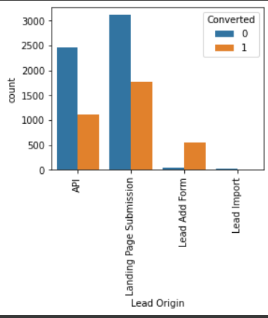

2. Lead Source

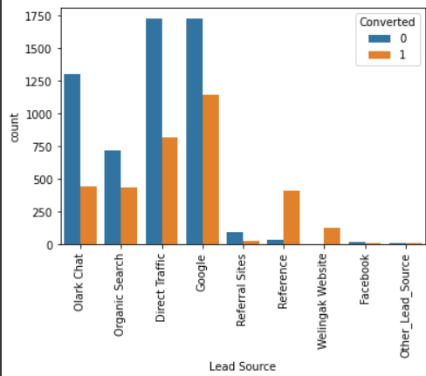

3. Last_Activity

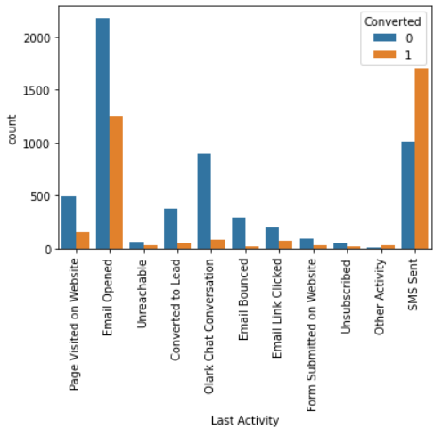

**2. What are the top 3 categorical/dummy variables in the model which should be focused the most on in order to increase the probability of lead conversion?**

Sol. :- The top three variables in my model, that should be focused are:

1. Lead: Source



2. Tags: chosen by Horizon

3. Tags: will revert after reading the email

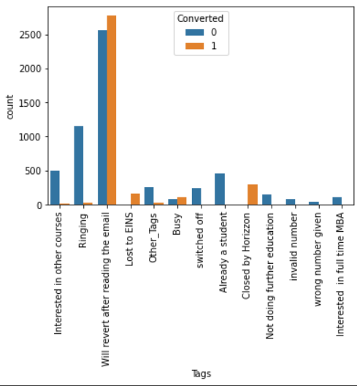

4. Last_Activity: SMS sent



**3. X Education has a period of 2 months every year during which they hire some interns. The sales team, in particular, has around 10 interns allotted to them. So during this phase, they wish to make the lead conversion more aggressive. So they want almost all of the potential leads (i.e. the customers who have been predicted as 1 by the model) to be converted and hence, want to make phone calls to as many of such people as possible. Suggest a good strategy they should employ at this stage.**

Sol. :-

● To focus on wider set of lead with –

Tags: will revert after reading the email

Total Time Spent on Website

Last_ Activity_SMS Sent

Tags_Lost to EINS

Last Activity_SMS Sent

Current occupation_Working Professional

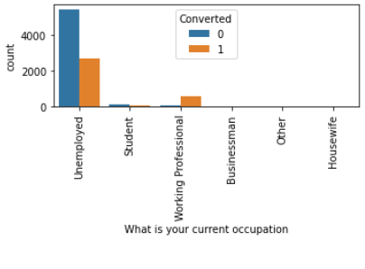

● Technically, we can generate this new set of leads by altering (moving down) the value of cut off so as to include more leads as the hot leads from our Logistic Regression Model

● Doing so, we will be better utilizing resources and improving the chance of converting a lead whose lead conversion probability might be low as well.

**4. Similarly, at times, the company reaches its target for a quarter before the deadline. During this time, the company wants the sales team to focus on some new work as well. So during this time, the company’s aim is to not make phone calls unless it’s extremely necessary, i.e. they want to minimize the rate of useless phone calls. Suggest a strategy they should employ at this stage.**

Sol. :- A good strategy will be:

● To focus more on the leads from Lead_Origin Quick Add Form

● and Tags lost to EINS (discarding lower conversion probable leads).

● Technically, we can generate this new set of leads by altering (moving up) the value of cut off so as to discard lower conversion rate probable leads from our Logistic Regression Model

● Doing so, we will be doing minimal effort and still be getting fair conversions.